**Unit 2 – Worksheet 2**

**Motion Maps**

Open the code found here for a simulation of a dog running at a constant velocity: <https://tinyurl.com/y89jru2k>.

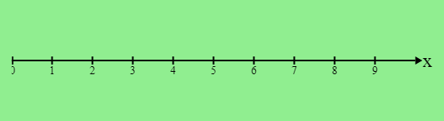

1. Complete the next-x function the same way we have in previous simulations. Set an initial position and velocity that will make the dog appear on the background above, where each tick represents one meter. Sketch what you see when your simulation ends.
2. Run the simulation again with a different velocity and initial position and sketch what you see when your simulation ends.
3. What things can you tell about the motion of your dog from looking at the motion map? How do these things show up on these motion maps?
4. Predict what the motion map will look like for the following initial conditions. Once you’ve made your predictions, test them with your simulation and draw the outcome of each simulation.

$x_{0}=1,v=2\frac{m}{s}$

$x_{0}=4.5,v=-1.5\frac{m}{s}$

$x_{0}=5,v=1.25\frac{m}{s}$

|  |  |
| --- | --- |
| **Prediction** | **Outcome** |
| C:\Users\jrutt\AppData\Local\Microsoft\Windows\INetCache\Content.Word\download.png | C:\Users\jrutt\AppData\Local\Microsoft\Windows\INetCache\Content.Word\download.png |
|  |  |
| C:\Users\jrutt\AppData\Local\Microsoft\Windows\INetCache\Content.Word\download.png | C:\Users\jrutt\AppData\Local\Microsoft\Windows\INetCache\Content.Word\download.png |
| C:\Users\jrutt\AppData\Local\Microsoft\Windows\INetCache\Content.Word\download.png | C:\Users\jrutt\AppData\Local\Microsoft\Windows\INetCache\Content.Word\download.png |

1. Determine the velocity and initial position of the dog in each case from the motion map it creates. Use your simulation to check your work.

|  |  |
| --- | --- |
| **Motion Map** | **Initial Conditions** |
|  | $x_{0}=$__________, $v=$ __________ |
|  | $x_{0}=$__________, $v=$ __________ |
|  | $x_{0}=$__________, $v=$ __________ |

The code below was used to generate a motion map:

|  |
| --- |
| x-initial = 4 #m  v = 1.5 #m/s  delta-t = 2 #s  **fun** next-x(x):  x + (v * delta-t)  **end** |

The map produced by this simulation is shown below, where each tick mark on the x-axis represents 1 meter.

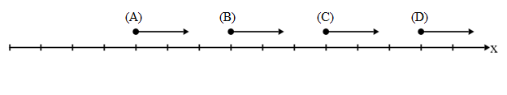

1. Identify which of the following calls of next-x would produce each dot.

|  |  |  |  |  |
| --- | --- | --- | --- | --- |
| next-x(0) |  |  | next-x(1) |  |
| next-x(3) |  |  | next-x(4) |  |
| next-x(5) |  |  | next-x(7) |  |
| next-x(10) |  |  | next-x(13) |  |

1. Fill in the function calls above with the value x would have after calling the next-x function with that input.